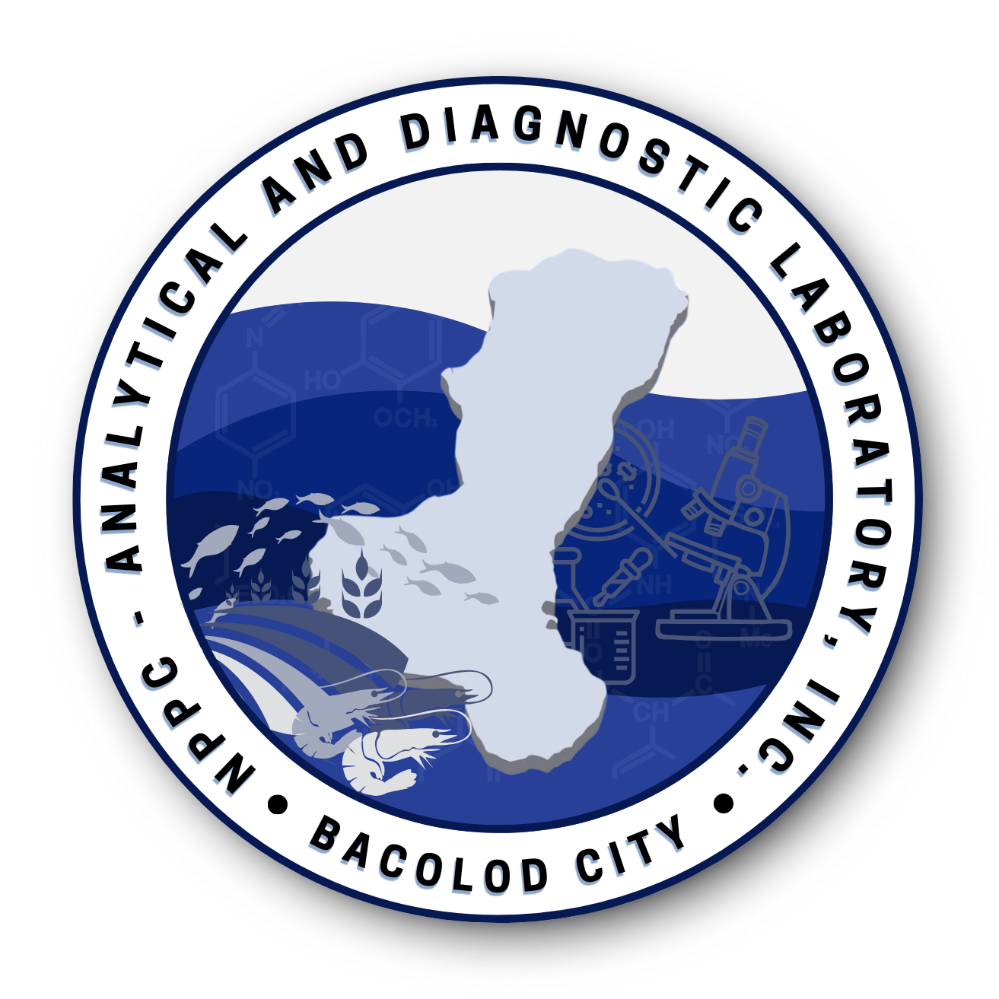
NPPC ANALYTICAL AND DIAGNOSTIC LABORATORY, INC.
Blk 2 Lot 29 San Vicente, Sta. Clara Subd., Circumferential Road, Brgy. Banago, Bacolod City
Tel. No. 034-4352613 email address nppclab@gmail.com

Customer :
Address :
Specimen :
Date Submitted :
Date Reported :
Test Requested : Nitrite Content
Reference No :

LABORATORY TEST RESULTS

Maximum Level = 167 mg/kg (Food Cat. No. 8.2.3 – DOH-BFAD)

NOTES : 1. Results of examination specifically related to samples as received.
2. Test results shall not be reproduced without the approval of the Laboratory Head.

Analyzed by: Approved by:

Ferresa Mae O. Caberoy, RCh Wendy A. Tayson, RCh, MEE
Laboratory Analyst Laboratory Head
PRC License No. 16125 PRC License No. 15131

NPPC ADL
LSP 7.8 F016
Rev 03 / Issue 04
Effectivity Date: 07/15/2026

